Glasgow on the Go: Visualising Urban Mobility in Glasgow

by

Danial Sheikh

In partial fulfilment of the   
requirements for the degree of   
Bachelor of Science

in

CS408: Individual Project

“Submitted for the Degree of BSc in ComputerScience”

Student number: 2020429578

Marking Scheme: Software Development Based

Except where explicitly stated all the work in this report, including appendices, is my own and was carried out during my final year. It has not been submitted for assessment in any other context.



Department of

Computer and Information Sciences

March 2023

Table of Contents

Abstract 1

Acknowledgements 2

1 Introduction 3

1.1 Problem Summary 3

1.2 Aims and Objectives 3

1.3 Outcomes of Project 4

1.4 Report Structure 4

2 Background Literature 5

2.1 Academic Research on Urban Mobility 5

2.2 Academic Research on GeoJSON Data 6

2.3 Comparison Analysis of similar applications 6

3 Specification and Design 9

3.1 Original Specification 9

3.2 Methodology 9

3.3 Requirements 10

3.3.1 User Stories 10

3.3.2 Functional Requirements 10

3.3.3 Non-Functional Requirements 11

3.3.4 System Use Cases 11

4 System Design 12

4.1 Design of Project 12

4.2 High-Level Architecture 12

4.3 User-Interface Design 13

4.3.1 User Interface Mock-ups and Role in Design 13

4.3.2 Responsive Navigation Bar 16

4.3.3 Aesthetic Design Choices 16

5 Detailed Design and Implementation 17

5.1 Technology Stack 17

5.1.1 DEVWEB 17

5.1.2 Gitlab 17

5.1.3 IntelliJ 17

5.1.4 CORS Proxy Server 17

5.1.5 REST API 18

HTML 5 19

5.1.6 CSS 19

5.1.7 JavaScript 19

5.1.8 Bootstrap 5 19

5.1.9 Leaflet 19

5.1.10 Chart.js 19

5.2 Application Development Process 20

5.2.1 Early Development and Focus on the Pedestrian Footfall 20

5.2.2 Using MVC structure moving forward 22

5.2.3 Decision to Diversify Pages 23

5.2.4 Graph Integration and Interactivity 24

5.2.5 Styling with Accessibility in Mind 27

5.2.6 Compliance with Accessibility Standards 28

6 Verification and Validation 30

6.1 Testing Strategy 30

6.2 Testing During Development 30

6.3 User Testing 30

6.4 Unit Testing 31

7 Results & Evaluation 32

7.1 User Experience Evaluation 32

7.1.1 Positives 32

7.1.2 Negatives 33

7.1.3 Possible Improvements 34

7.2 Comparison with Specification 34

7.3 Final Evaluation of Application 34

8 Summary and Conclusion 35

8.1 Project Reflection 35

8.2 Future Development 35

8.2.1 Short-Term Development Opportunities 35

8.2.2 Long-Term Development Opportunities 35

8.3 Conclusion 36

9 Bibliography 37

10 Appendix A- Model Checks User Input 40

11 Appendix B- User Testing and User Evaluation: 42

11.1 Ethical Approval Form 42

11.2 Consent Form 42

11.3 User Tasks 43

11.4 Survey Questions 44

12 Appendix C- User and Maintenance Guide 46

12.1 Prerequisites 46

12.2 Accessing as a User 46

12.3 Deploying the Application as Maintainer or Developer 46

13 Appendix D- Unit Testing 48

# Abstract

This dissertation provides a comprehensive overview of the 'Glasgow on the Go' project; an interactive application designed to visualise urban mobility within Glasgow examining pedestrian, cyclist and traffic flow data from the Glasgow Open Data Hub. The central aim was to render complex mobility data into an accessible format that was visually appealing and easy to understand, thus supporting urban planning and policymaking. The application was developed using JavaScript and an array of web technologies. The project strictly adhered to WCAG 2.1 AA standards for accessibility. The application incorporated REST APIs for the integration of real-time data, situating itself firmly within an agile, user-centred design process bolstered by biweekly supervisor feedback.

The application enables users to engage with and analyse mobility patterns for Glasgow across specific date ranges, providing valuable insights for urban mobility considerations. Rigorous testing corroborated the application’s operational soundness and effectiveness thereby contributing to advancing sustainable urban development for Glasgow.

# Acknowledgements

Firstly, I would like to thank my supervisor for this project Dr Fredrik Nordvall Forsberg, for his advice and support throughout the project, particularly for his unwavering patience during my coding challenges. I would also like to thank Dr Alex Coddington, for her valuable feedback on my presentation that gave me a more insightful perspective going forward.

I would also like to say thank you to my family and friends for motivating and putting up with me when dealing with the difficult stages of the project.

I would also like to extend my gratitude to everyone who participated in my user study for their input and feedback on the usability and functionality of my application along with suggested improvements.

# Introduction

## Problem Summary

Glasgow is a bustling and vibrant city, and the way people navigate their way around it has a huge impact on important matters such as traffic jams to air pollution levels. According to the Glasgow Times, “Glasgow’s population has been steadily increasing since 2006 when it was 568,480. In 2019, it was recorded as 633,120” [1]. This figure is expected to continue rising putting increased pressure and demands on the existing infrastructure, especially with implications for transport planning on future expansion needs. An article from Scottish Television highlighted this issue with people on record saying “It’s the worst it’s ever been” [2]. This is what people who rely on public transport in Glasgow are saying about the services. Rising transport costs and lack of available services could potentially lead to an increase in car usage. This will discourage healthier and more sustainable modes of travel, like walking and cycling. Addressing the problems of urban mobility can pave the way for a sustainable Glasgow that benefits future generations.

## Aims and Objectives

The aim of this project is to monitor and visualise urban mobility in Glasgow. I decided to do this by utilising datasets provided by the Glasgow Open Data Hub and visualising them in an appealing and easy to understand way. This was done by designing an application using JavaScript as the primary programming language. The three different datasets from Glasgow Open Data Hub highlight pedestrian, cyclist and traffic flow throughout Glasgow. I decided the best approach to retrieve and access the data would be through an Application Programming Interface (API) for each dataset. Users can input two specific dates between which they want to view the data, and this is presented to them through an interactive map and graph.

To achieve the main aim of this project, I followed five key objectives:

* **Data Collection and Integrity**: Collect and display the data from the Glasgow Open Data Hub. The data is directly from the Glasgow City Council which is a credible and concrete source.
* **Comprehensive Mobility Coverage**: The data should cover pedestrians, cyclists and vehicles to fully showcase Glasgow’s urban mobility. This approach allows for a nuanced understanding of the city’s movement, essential in making informed urban planning decisions.
* **User Data Exploration:** Allow users to enter a specific date range and filter results ensuring the data is relevant to their needs. By facilitating user-defined date ranges, the application not only allows for a customised view of urban mobility but also aids users in making informed decisions based on the specific time frames that matter to them.
* **Interactive Visual Tools Development**: Develop and implement an interactive graph and map which offers users a dynamic platform to engage with urban data.
* **Clarity and Accessibility in Visualisation:** Helping users visualise complex urban mobility data in a clear and concise manner. This will allow users from many backgrounds to easily grasp and interpret Glasgow’s urban movements.

## Outcomes of Project

The outcome of this project has resulted in a fully functional application that illustrates urban mobility in Glasgow. The application provides users access to the most current and historical pedestrian, cyclist, and traffic data. This offers an insight into Glasgow’s urban mobility over time. The application consists of a homepage and three separate pages for each different data type (pedestrian, cyclist, and traffic). The application displays the data through an interactive map and graph giving two different ways to visualise the data. The map and graph are connected. If you were to click on a certain bar on the graph, it would take you to the exact location pinpointed on the map. Various filter options allow the user to obtain the relevant results.

## Report Structure

This report begins with an Introduction which sets the stage, outlining the pressing urban mobility challenges faced by Glasgow and the project's aims to address these through the innovative visualisation of data. The Background Literature review includes relevant academic research, setting the conceptual framework for the application's design. Subsequent chapters detail the Specification and Design of the system, the Methodology adopted for the development, and the intricate processes of Detailed Design and Implementation that brought the project to fruition. A thorough account of Verification and Validation provides insight into the rigorous testing employed, ensuring the application's reliability and efficiency. The Results & Evaluation chapter critically assesses the user experience and the application's performance against its initial specifications. The final chapter Summary and Conclusion, reflects on the project's achievements, its limitations, and the potential avenues for future research and development. Appendices provide supplementary material, including ethical approval forms and testing documentation.

# Background Literature

## Academic Research on Urban Mobility

The paper “Transport Issues and Sustainable Mobility in Smart Cities” addresses the complexity of urban mobility and city sustainability [3]. It highlights the significance of using geographical data to clearly illustrate urban planning and policymaking, a concept key to my project on visualising Glasgow's urban mobility. Furthermore, the paper also highlights the importance of the need for tools that offer real-time accessible information. This reinforces the aim of my project to create an interactive map and graph that can help users observe mobility patterns in Glasgow.

## Academic Research on GeoJSON Data

For urban mobility, GeoJSON is a powerful tool for visualising complex datasets. This is proven by Esri’s analysis of human mobility patterns using this data tool [4]. This article suggests the methodological approach to creating an interactive map of Glasgow, using GeoJSON which is a sound method for depicting urban mobility.

## Comparison Analysis of similar applications

The case study carried out on visualising São Paulo's urban mobility with various techniques offers valuable insights into data visualisation [5]. The paper illustrates how complex mobility data can be simplified to ensure end users can analyse and understand it. For presenting and analysing the urban mobility data the study used the bundling method. This technique is used to simplify and clarify the presentation of large sets of data. I am planning to apply this to present Glasgow’s mobility data on an interactive map and graph.

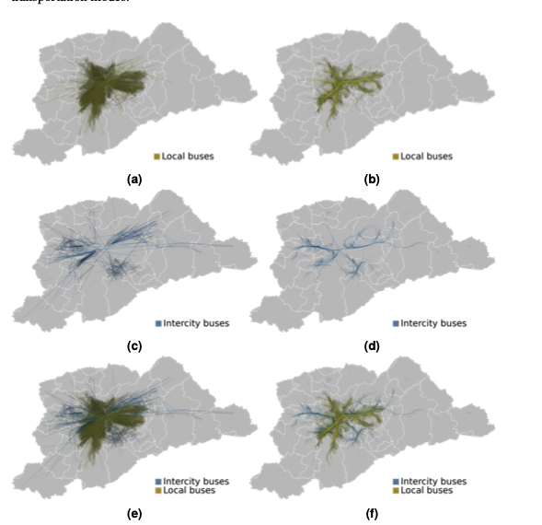

Figure 1: Naïve straight-line drawing of OD trails from the Metropolitan area of São Paulo.

Figure 2: Naïve straight-line drawing of OD trails form the Metropolitan area of São Paulo.

Figure 1 shows Origin-Destination (OD) Survey trajectories plotted over the map of the São Paulo metropolitan area, where each line represents an OD trail. The extreme clutter in this figure precludes the visualisation of individual trajectories, traffic patterns, or connections between the regions of the map [5].

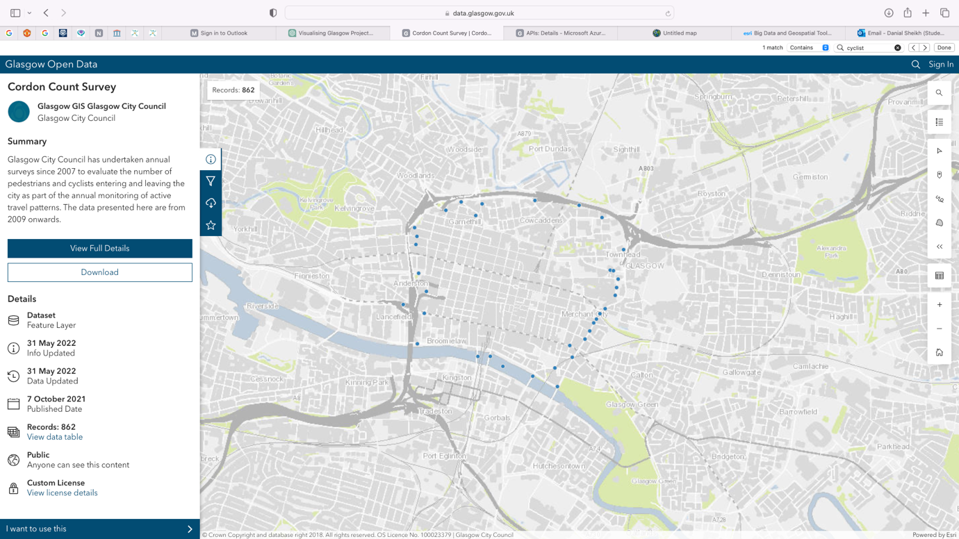

Figure 2: Glasgow Open Data Hub Cordon Count Survey.

The map in Figure 2 from the Glasgow Open Data Hub displays the Cordon Count Survey data, showing the number of pedestrians and cyclists. It shows data from 2009 onwards. It clearly illustrates Glasgow’s active travel and urban mobility. I am hoping my application improvs upon this by being more interactive and visually appealing to users.

# Specification and Design

## Original Specification

The foundations of this project were conceptualised by my supervisor, Dr Fredrik Nordvall Forsberg. The original project specification read as follows: “Glasgow City Council provides a vast amount of data through the Glasgow Open Data Hub [6]. The goal of this project is to select some of these datasets that you find interesting and visualise them in an appealing way. You might want to take inspiration from other visualisations such as engaging data [7]. The choice of implementation language is up to you, but clearly, a high-level language with good graphics support such as Python or JavaScript might be preferable.” When reviewing the datasets provided by Glasgow Open Data Hub, I was drawn to the untapped potential of urban mobility data. Thus, I directed my efforts towards developing an application which visualises urban mobility in Glasgow, making the data visually appealing and easy to understand for both public use and urban planning.

## Methodology

In developing the application, I opted to use an Agile development approach. A key reason behind this was its flexibility and capacity for iterative development. I met with my supervisor Fredrik Forsberg Nordvall every fortnight for our stand-up meetings. This allowed for regular feedback and continual improvement when building the application. To manage my workload effectively, we organised it into sprints. This strategy ensured the setting of realistic deadlines but allowed for flexibility to adapt to the evolving requirements of the application. The consistent dialogue ensured that my project remained aligned with its aims and objectives.

When selecting an agile methodology for the project between waterfall or spiral, three key advantages stood out:

* **Flexibility and Responsiveness**: Agile enabled me to make quick adjustments to my project based on both user and supervisor feedback. This would present a challenge if I used a waterfall method instead due to its rigid structure and lack of flexibility.
* **Efficiency and Speed**: Agile sprints accelerated the application’s development allowing for more prototyping and sprint iterations. This was instrumental in improving the features of the application, particularly for visualising the data. A task that would have been delayed under the linear approach of waterfall.
* **Improve Risk Management**: Agile allowed me to make swift changes during the development of my application based on suggestions from my advisor and ongoing development issues. Whereas a spiral model, whilst methodical in addressing risks through pre-planning, would not offer the same adaptability for solving real-time problems as they arise.

## Requirements

### User Stories

* As a commuter, I want to check traffic so I can avoid congested routes.
* As a city planner, I want to understand peak footfall areas to better plan urban infrastructure.
* As a researcher, I want to extract data for academic purposes to facilitate my study of urban trends.
* As a policymaker, I need to compare historical and current data to assess the impact of new policies.
* As an urban developer, I want to access pedestrian flow patterns to design better public spaces.
* As someone relocating to Glasgow, I would like to find the least congested parts of the city, so I can live in a noise-free environment.

### Functional Requirements

The functional requirements for my application are as follows:

* The system shall provide an interface for users to input specific data ranges to retrieve data.
* The system shall offer different pages for each form of mobility data (Pedestrian, Cyclist and Traffic).
* The system shall present an interactive map and graph interface of Glasgow that displays the mobility data corresponding to the user’s input.
* The system shall enable interactive features such as zoom, scroll and selection within the map and graph to aid user analysis.

### Non-Functional Requirements

The non-functional requirements for my application are as follows:

* **Compatibility:** The system should work effectively across a range of devices and web browsers. This ensures broad accessibility and convenience for users with different devices.
* **Accessibility:** The system should adhere to WCAG2.1 AA standards and demonstrate a commitment to users with special needs. Thus ensuring the application is usable by as many people as possible.
* **Real-time Synchronisation**: The system will update dynamically, reflecting the latest data from Glasgow Open Data Hub APIs, to maintain the timeliness and accuracy vital for user decisions and analysis.
* **Data Exportability**: The system ensures the graph is downloadable in various formats, facilitating ease of use for presentations, reports, and personal records.
* **Ease of Navigation and Visual Appeal**: The system design will prioritise intuitive navigation and aesthetic design, ensuring information is not only accessible but also presented in a manner that enhances user experience, understanding and analysis.

### System Use Cases

* A user selects a location to view traffic trends for that area.
* A user clicks on a pin on the map to get more details about footfall at a specific location.
* The developer in charge of the application (me) should ensure the information from the API is processed correctly and displayed in real time to the user.
* A user filters the data for a specific time period so they can study its impact on urban mobility.
* A user navigates between pages, and it is easy to access the relevant data.

# System Design

## **Design of Project**

This chapter gives an insight into the design process of my application, detailing how each design decision aligns with my project aims and objectives. It will unpack the rationale behind the selected technology stack, the architectural design of the application and the user focused design approach. It will also touch upon the strategies implemented to ensure accessibility standards are met and performance is as expected.

## **High-Level Architecture**

For structuring the application, I decided to follow a Model View Controller (MVC) approach. MVC helps break up front-end and back-end code into separate components making the code more manageable:

* **Model**: The model is the back-end of my application. It interacts with the Glasgow Open Data Hub API to fetch the data for each different page, whilst also querying the logic of user requests.
* **View**: The front end of the application presents the processing of the sorted data from the model. It presents the data in an easy to understand and user-friendly way, by generating the interactive map and graph. It updates based on the data provided by the model through the controller.
* **Controller**: The brains of the application which handles the user interactions and application responses. It makes calls to the model to retrieve the appropriate data based on user requests, such as selecting certain timeframes for mobility data and then passes this data to the View to make it presentable.

The data flow in the application begins when the user interacts with the interface, entering two dates and clicking the submit button. The action then triggers the controller which uses data logic methods in the model to sanitise and validate user input, this ensures the dates are in the correct format. After this happens, the Controller calls the Model’s ‘**getDataFromAPI()**’ method and passes in the two dates. The model makes an API request to the Glasgow Open Data Hub and processes the received data. Once the data is ready, the Model sends it to the View where it is used to render the interactive map and graph. Visually representing the traffic, pedestrian or cyclist data depending on what page they are on.

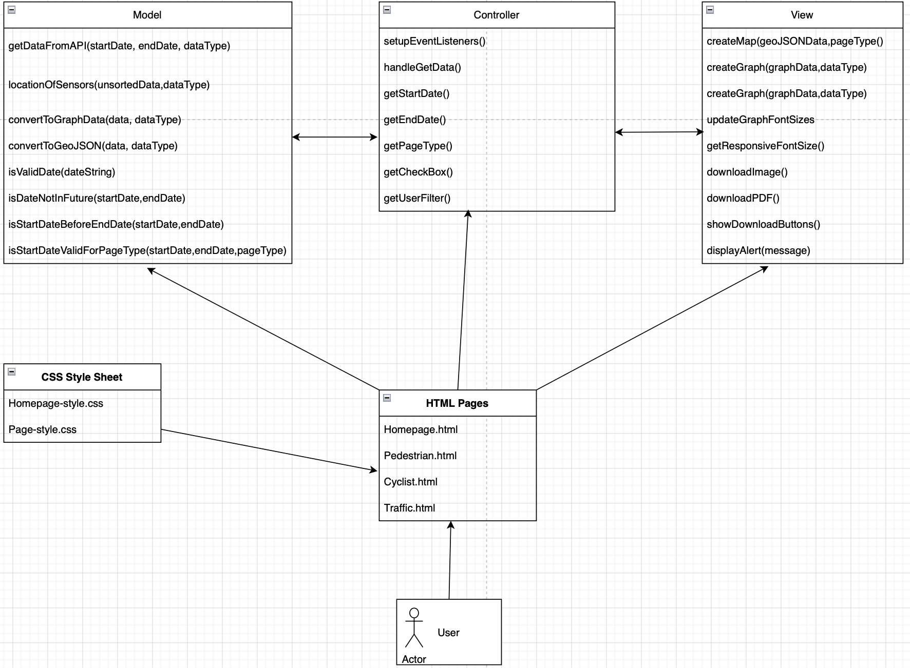

Figure 3: This shows the high-level architecture of the application.

## **User-Interface** Design

This part of my dissertation examines the user interface design process of the application. It demonstrates how I focused on user-centred design principles which guided the creation of a responsive, accessible, and aesthetically pleasing user experience. Then I will outline the creation of user interface mock-ups to help visualise the layout of the page elements.

### User Interface Mock-ups and Role in Design

During the initial phase of the design process, various user interface (UI) mock-ups were created to conceptualise the layout and interaction flow of the application. These mock-ups were created using an online software called Figma. These mock-ups served as a visual guide, allowing for early detection of potential usability issues, and ensuring the functional and non-functional requirements of the application are met.

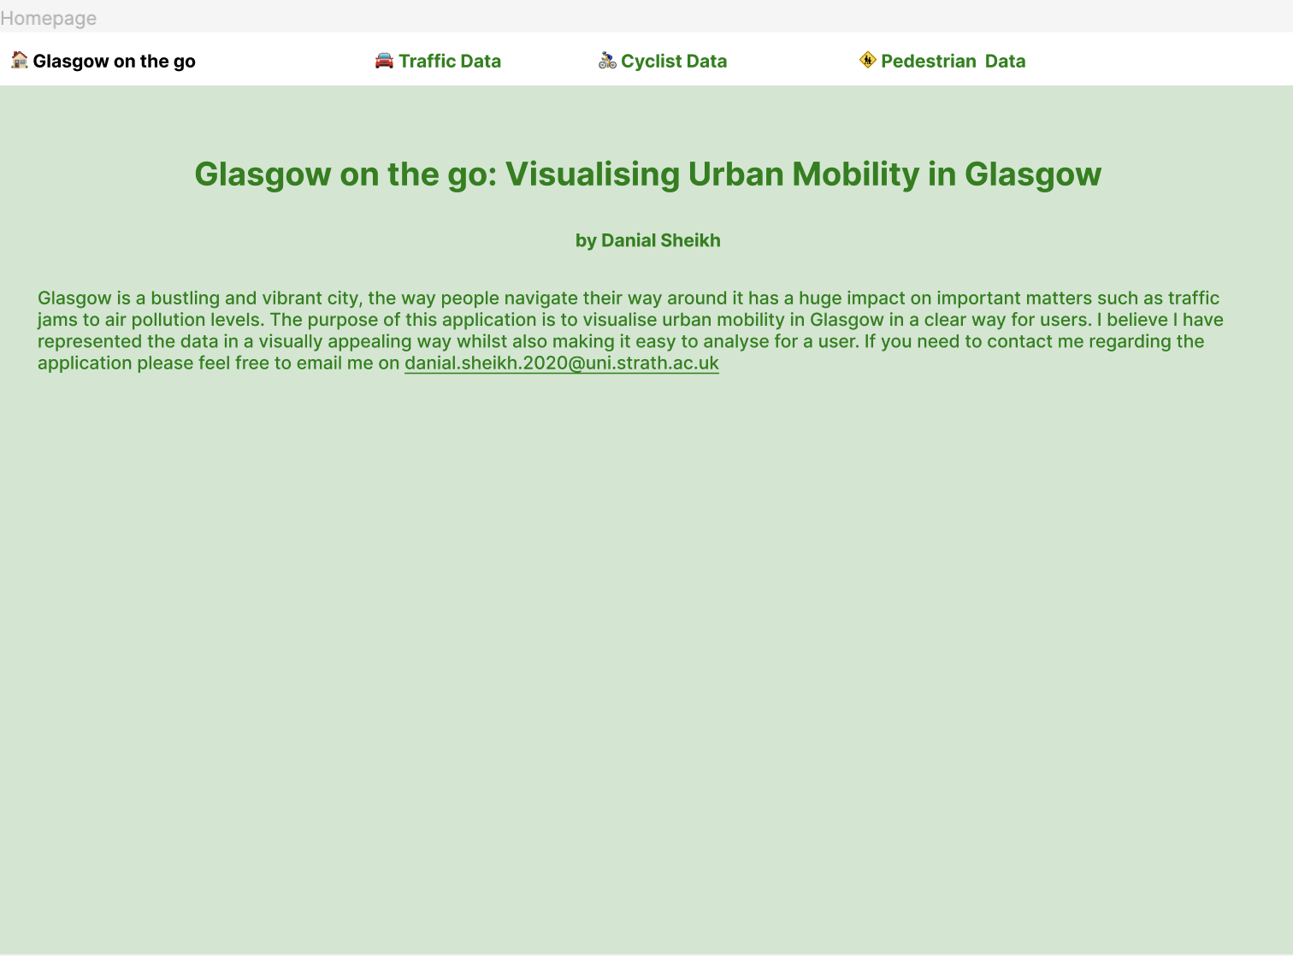

Figure 4: This shows the homepage mock-up.

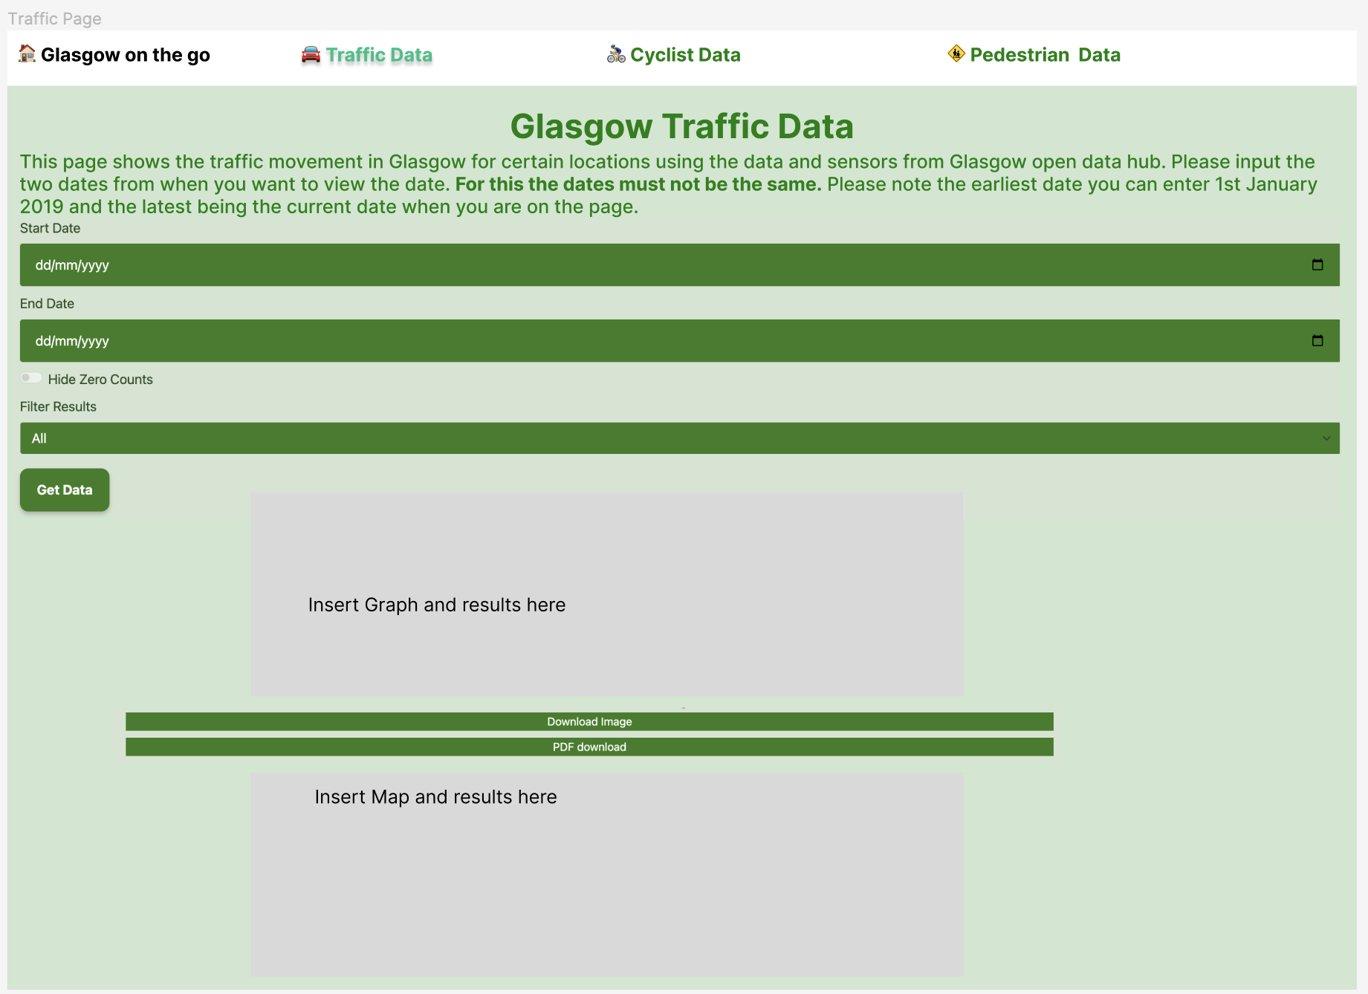

Figure 5: This shows the Traffic Page Mock-up (besides the title and description at the top, it has the exact same layout/ functionality for other pages).

In Figure 4 the homepage serves as a gateway to the application. It embodies the essence of the system use cases by providing an intuitive navigation system. This allows users to commence their interaction seamlessly through the navigation bar at the top. Also, in line with the non-functional requirement, the application adjusts across different device screen sizes and adheres to WCAG 2.1 AA standards, ensuring it is accessible to all users. The prominence of navigation features in the mock-up underscores the application's commitment to intuitive user experience, a core principle of user-centred design.

Figure 5 shows the Traffic Page Mock-up which illustrates the application’s core functionality and the visualisation of where the traffic data will be placed. The mock-up shows the user interface for selecting dates and filtering options which are in alignment with meeting two key functional requirements. The layout of this page is a testament to user stories such as a commuter wanting to check traffic to avoid congested routes.

### Responsive Navigation Bar

The navigation bar design was engineered to be fully responsive, which is a key feature that ensures that the content is adapted for various screen sizes and resolutions in alignment with mobile first design principles. For smaller screens, the navigation options turn into a ‘hamburger’ icon- a familiar element that users can tap to expand the navigation bar. This ensures that the navigation remains accessible without crowding the screen, ensuring users have a seamless experience on smaller screen sizes.

### Aesthetic Design Choices

For the application I have chosen a green colour scheme, this reflects a commitment to creating a visually soothing experience while still promoting focus and readability. This colour also reinforces the theme of urban mobility with the association of progress and sustainability.

The application adapts the font size dynamically to ensure legibility on various screens, from large desktop monitors to compact mobile displays. This responsive typography ensures that the content on the screen is easy to digest, regardless of the device.

Interactivity is a key aspect of the user experience. A notable feature is the integration between the data representations. Clicking on a bar with the interactive bar chart opens the corresponding detailed pinpoint on the map. This interaction allows users to have a better analysis experience by diving into deeper specific data points without losing context.

User interface elements including forms, buttons and fields designed with a clear hierarchy and ample spacing between elements. The user interface elements are responsive to user screen size and accommodate a wide range of user interactions ensuring the application remains approachable and intuitive across all devices.

# Detailed Design and Implementation

Once the system design had been decided, the actual development of the application then took place. As the user interface mock-ups had been created, it made the implementation and layout of the application a lot more straightforward.

## **Technology Stack**

Numerous technologies were used to ensure the project was completed to a high standard and ensure the aims and objectives were met.

### **DEVWEB**

The application was hosted on the University of Strathclyde DEVWEB server. The server allowed me to see how the application functioned in a real time environment whilst also quickly uploading the changes I was making during development. In a later chapter for my user testing, it allowed multiple users to use the application through a URL without having to go through the setup on their machine.

### **Gitlab**

This was the platform of the version control provided by the university. I used this to commit, pull and push versions of my application’s source code. I picked this as I had used it previously, and it was intuitive to use. This and the DEVWEB section mentioned above gave me another independent source to back up my project files.

### **IntelliJ**

IntelliJ is an integrated development environment, that was used to develop and program my application. I chose it as I had previous experience of using it for projects and it allowed for the easy integration of frameworks and plugins throughout my project. Examples of this are the easy upload of my code to DEVWEB or Gitlab.

### **CORS Proxy Server**

In web development, Cross-Origin Resource Sharing (CORS) is a security feature that restricts web applications that make cross-origin HTTP requests. During development, I could not request the Glasgow Open Data Hub API because of this CORS security problem. To overcome this, I utilised a CORS proxy server [8] . This proxy acts as an intermediary which adds the necessary CORS headers to the responses from the external APIs hosted on the Glasgow Open Data Hub.

let urlPedestrian = `https://corsproxy.io/?` + encodeURIComponent(`https://api.glasgow.gov.uk/mobility/v1/footfall/historical?format=json&startDate=${startDate}&endDate=${endDate}`);  
let urlCyclist = `https://corsproxy.io/?` + encodeURIComponent(`https://api.glasgow.gov.uk/mobility/v1/Mobility_Measurements?format=json&period=day&type=bicycle&date=${startDate}&end=${endDate}`);  
let urlTraffic = `https://corsproxy.io/?` + encodeURIComponent(`https://api.glasgow.gov.uk/traffic/v1/movement/query?start=${startDate}&end=${endDate}&period=Day`);

The CORS proxy server played a pivotal role in my application as without it users could not fetch any urban mobility data. While this approach facilitated the development process by allowing API requests to be made without direct CORS support, it is recognised that using a proxy may introduce security considerations that would not be suitable for a production environment.

### **REST API**

When it came to accessing the data from the Glasgow Open Data Hub I did so through a REST API (Application Programming Interface). Representational State Transfer (REST) is an architectural style that allows communication between a client and a server in a scalable and stateless manner, primarily using HTTP requests [9]. This approach allows for efficient data retrieval from Glasgow Open Data Hub via HTTP ‘GET’ requests, aligning with REST principles to provide a fast and seamless user experience.

The ‘GET’ request, when successful, returns a JSON response containing the data relevant to the user's query, which includes the count and location from the sensor, as well as the date range specified by the user. This data is then parsed and manipulated to extract the precise information needed for display from the JSON response. The process involves filtering the JSON response to isolate specific values and transform them into a format that can be easily used to plot on the map and graph. This step is crucial as it ensures that users receive a tailored view of the urban mobility data they are interested in.

### **HTML 5**

Hypertext Mark-up Language 5 is used to structure website design. I used this to structure the four web pages and manipulate the elements through JavaScript.

### **CSS**

Cascading Style Sheets are used to style an HTML document, thus making it more visually appealing to users.

### **JavaScript**

JavaScript is a scripting language that allowed me to add client-side functionality to my web pages so users could interact with them. This played a significant part in allowing me to make all my web pages responsive. Most of the application’s functionality relied on JavaScript throughout the development.

### **Bootstrap 5**

Bootstrap is a CSS framework that plays a key role in making the application responsive and compatible with both mobile and desktop devices. The bootstrap framework was selected to help with the responsiveness of the application through its container system. Bootstrap's container system utilises a series of responsive, fixed-width, and fluid-width settings that serve as the foundation for the layout of the application. Alongside media queries, this ensured content alignment and consistency across different screen sizes.

### **Leaflet**

Leaflet is a lightweight open-source JavaScript library for the development of interactive maps [10]. The key features of Leaflet were that its selection in this project included its lightweight nature, vast documentation, and variety of plugins. It is also desktop and mobile-friendly to ensure user-friendliness and accessibility. Leaflet allowed me to ensure the completion of my project objective of building an interactive map.

### **Chart.js**

Chart.js is a versatile open-source JavaScript library that specialises in creating interactive and animated charts with a simple API [10]. Its integration into the project was pivotal for presenting urban mobility data in an engaging and easily digestible format. The utilisation of Chart.js contributed to the achievement of the project's objectives by making statistical data on urban mobility both accessible and understandable to a broad audience. This aligns with the aim of visualising data in a clear way and facilitating its interpretation and analysis through interactive elements.

## **Application Development Process**

### **Early Development and Focus on the Pedestrian Footfall**

The initial phase of my development journey began with a concentrated effort on the pedestrian footfall feature. It began with making an HTTP ‘GET’ request to the footfall API. This request was crafted by appending user inputted start and end dates into the request URL, and it was executed using JavaScript's **fetch** and **await** syntax, as illustrated in the following code snippet:

try {  
 const response = await fetch(url, {method: 'GET'});  
 if (!response.ok) {  
 ***window***.alert("Cannot connect to the Glasgow Open Data Hub, please try your request later.")  
 }

Upon successful retrieval, the JSON data was parsed to extract pedestrian counts and locations. The process of converting to GeoJSON involves encapsulating each location's data into a structure called a 'Feature' within a 'FeatureCollection'. Each ‘Feature’ comprises properties containing the pedestrian count, a string of associated dates, and a geometry specifying the data as a 'Point' with longitude and latitude coordinates.

const aggregatedData = {};  
if (dataType === 'pedestrian') {  
  
  
 data.forEach(item => {  
 const street = item.location.description;  
 const coordinates = [item.location.longitude, item.location.latitude];  
 const date = new ***Date***(item.processDate);  
 const day = String(date.getUTCDate()).padStart(2, '0');  
 const month = String(date.getUTCMonth() + 1).padStart(2, '0');  
 const year = date.getUTCFullYear();  
 const monthYear = `${year}-${month}-${day}`;  
  
 if (!aggregatedData[street]) {  
 // If the street key doesn't exist, create it with initial values  
 aggregatedData[street] = {  
 pedestrianCount: 0,  
 coordinates: coordinates,  
 description: street,  
 dates: [] // Array to store all dates for this street  
 };  
 }  
  
 // Aggregate the pedestrian counts for the street key  
 aggregatedData[street].pedestrianCount += item.pedestrianCount;  
 if (!aggregatedData[street].dates.includes(monthYear)) {  
 aggregatedData[street].dates.push(monthYear);  
 }  
 });  
  
 // Convert the aggregated data into an array of GeoJSON features  
 const features = ***Object***.keys(aggregatedData).map(key => {  
 const item = aggregatedData[key];  
 return {  
 "type": "Feature",  
 "properties": {  
 "pedestrianCount": item.pedestrianCount,  
 "dates": item.dates.join(', '), // Join dates as a string  
 "description": item.description  
 },  
 "geometry": {  
 "type": "Point",  
 "coordinates": item.coordinates  
 }  
 };  
 });  
 return {  
 "type": "FeatureCollection",  
 "features": features

This conversion to a 'FeatureCollection' in GeoJSON format is pivotal for the application's interactivity and the creation of a map. Each 'Feature' represents a unique location on the map with associated mobility data in the code snippet above which is pedestrian. When a user clicks on a feature point on the map, the application triggers a popup that displays this detailed information, drawn directly from the GeoJSON properties. The inclusion of all data points as individual 'Features' within the 'FeatureCollection' means that this interactive capability is uniformly available across the map. Therefore, it’s not limited to certain points; any point that has been transformed into a GeoJSON 'Feature' and included in the 'FeatureCollection' will have this clickable functionality, ensuring a consistent user experience.

### **Using MVC structure moving forward**

The successful implementation of pedestrian data visualisation in the application led me to refactor my codebase. Adopting the Model View Controller (MVC pattern), I enhanced the code’s structure and maintainability for the application for long-term use going forward. The MVC framework allowed for a cleaner separation of the application's logic, user interface, and underlying data model.

For the application:

* Model (‘model.js’) acts as a data hub for managing all data logic fetching. This then processes and formats mobility data into the correct layout for the rest of the application. It also ensures that user input is sanitised when entering the start and end date.
* View (‘view.js’) is the presentation layer of the application focusing on the design of elements that users interact with, such as the map and graph and other analysis options. The View receives the data processed by the Model ensuring users can interact and visualise the data seamlessly.
* Controller(‘controller.js’): operates as an intermediary. The Controller binds the Model and View together. It listens for user inputs and commands through event listeners relaying these to the Model for data updates and to the View for changes in the display.

This made testing and debugging the program much easier as each component could be modified or augmented independently. By clarifying the responsibilities of different parts of the code, the MVC approach also makes the codebase and repository easier to understand for future developers. Furthermore, this approach streamlines the introduction of new features, negating the need for extensive rewrites or complex restructuring of the entire application.

### **Decision to Diversify Pages**

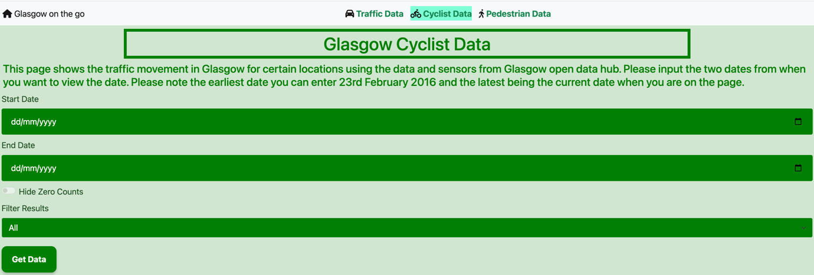

Figure 6: Highlights the Cyclist tab as you are on the cyclist page.

Originally, the application was envisaged as a single page. However, accessibility concerns and user design considerations steered it towards a multi-page approach. A homepage (‘index.html’) which introduces what the application does and dedicated separate pages for pedestrian(‘Pedestrian.html’), cyclist(‘Cyclist.html’) and traffic(‘Traffic.html’).

<body data-page-type="pedestrian">

<body data-page-type="cyclist">

<body data-page-type="traffic">

To maintain consistency in style, and interactivity and to avoid code duplication, each page is assigned a specific **data-page-type** attribute within the **<body>** tag, such as **<body data-page-type="pedestrian">** for pedestrian data. While each page calls the same scripts for functionality, the **data-page-type** attribute serves as a conditional check within the scripts to determine which page-specific functions to execute. This approach reduces the need for multiple separate versions of MVC files, allowing for a more streamlined and manageable codebase. It also simplifies the process of introducing updates or new features, as modifications to the core functionality can be made in one place and reflected across all pages.

In Figure 6 you can see the cyclist tab highlighted which correlates to the user being on the cyclist page. Implementing the navigation bar was greatly facilitated by using Bootstrap 5 and custom CSS. Moreover, the navigation bar was structured to present a logical flow of information, reflecting the importance of user journey mapping in the design process. It provided a clear and organised means for users to access data on pedestrian, cyclist, and traffic movements, supporting efficient and targeted exploration of urban mobility data within Glasgow.

### **Graph Integration and Interactivity**

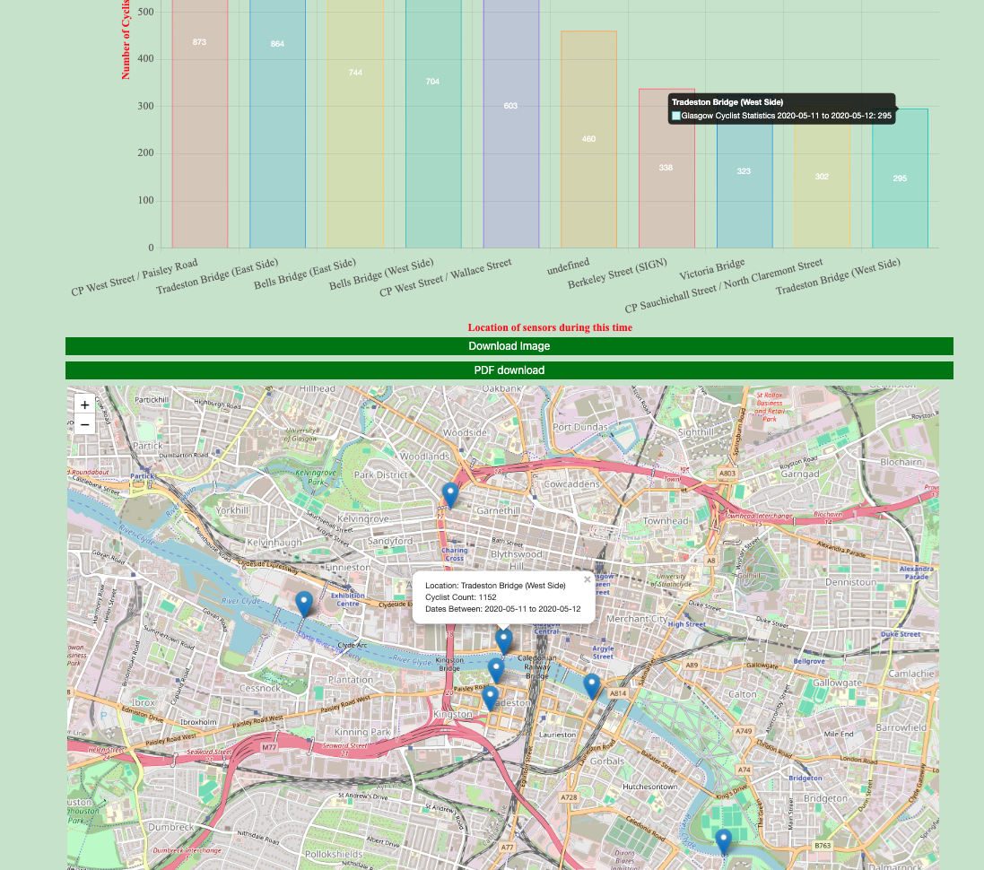

Figure 7: Clicking on a bar on the graph opens the pop-up marker of the same location on the map.

Between January to March, I focused on adding a graph (using Chart.js) to accompany the map (using Leaflet), thus providing a dual approach to data visualisation [11]. This met many functional and non-functional requirements but also allowed users to choose their preferred data analysis method. An interactive feature was added where if a user clicked on a data point on the graph it would highlight the corresponding location on the map. This gives the user the choice of using both simultaneously. This is illustrated in Figure 7.

To implement the interactive data point on the graph, event listeners were implemented within the Chart.js configuration, which is central to this functionality:

onClick: (event, elements,) => {  
 if (elements.length) {  
 const firstPoint = elements[0];  
 // Corrected from firstElement to firstPoint  
 const label = this.Graph.data.labels[firstPoint.index];  
 const marker = this.mapMarkers[label];  
 if (marker) {  
 marker.openPopup();  
 this.map.setView(marker.getLatLng(), 14); // Or any other zoom level  
 }  
 }

The above code demonstrates how clicking on a bar in the graph highlights the corresponding location on the map. The ‘onClick’ function serves as a bridge between the graph and the map. A simple click on a data point on the bar graph triggers a visual cue on the map where a popup emerges and the view zooms into the corresponding geographical point. This connection between Chart.js and Leaflet provides a dynamic user experience, allowing for an intuitive and informative exploration of the specific mobility data across Glasgow.

Incorporating real-time user feedback mechanisms, I integrated a loading spinner using Bootstrap and custom CSS. This feature reassures users during data processing after submitting their query.

// Show loading spinner  
 const spinner = ***document***.querySelector('#submitButton .spinner-border');  
 spinner.classList.remove('d-none');  
  
 this.model.getDataFromAPI(startDate, endDate, pageType).then(data => {  
***…***  
 }).catch(error => {  
 ***console***.error('Error fetching/handling data', error);  
 })  
 .finally(() => {  
 // Hide loading spinner  
 spinner.classList.add('d-none');  
 });  
 }

The above snippet demonstrates the integration of a loading spinner that provides users with visual feedback during data retrieval. Bootstrap's spinner components, combined with custom CSS, ensure that users are aware of ongoing data processing. The spinner is displayed while the application fetches data and is hidden upon completion, enhancing the user experience with responsive visual cues.

After this I added a data filtering option, allowing users to sort results by varying criteria, including the ability to hide zero counts. Thus fine-tuning the data displayed according to their preferences and relevance.

if (***controller***.getCheckBox().checked === true) {  
 const filteredIndices = yAxis  
 .map((count, index) => ({count, index}))  
 .filter(item => item.count > 0)  
 .map(item => item.index);  
 xAxis = filteredIndices.map(index => xAxis[index]);  
 yAxis = filteredIndices.map(index => yAxis[index]);  
}  
  
let selectionValue = ***controller***.getUserFilter();  
if (***controller***.getUserFilter() !== 'all') {  
 selectionValue = parseInt(selectionValue.replace('top-', ''), 10);  
 let sortedData = yAxis  
 .map((count, index) => ({count, index}))  
 .sort((a, b) => b.count - a.count)  
 .slice(0, selectionValue);  
 xAxis = sortedData.map(item => xAxis[item.index]);  
 yAxis = sortedData.map(item => item.count);  
}

For the code snippet above here is a breakdown of what it does:

* **Data Filtering Mechanism:** Using ‘**controller.getCheckBox().checked === true’**, the interface provides a toggle to filter out inactive data points, such as locations with zero pedestrian, cyclist or traffic count depending on the page. This allows users to focus on more relevant data.
* **Ranking and Selection**: The top mobility count triggered by ‘**controller.getUserFilter()’** dynamically ranks the mobility data from highest to lowest. Then allows users to pick between the top five to the top twenty results. It utilises JavaScript's **‘sort()’** and ‘**slice()’** to display the most active locations, allowing users to prioritise information according to pedestrian, cyclist, or traffic data.
* **Ranking and Selection:** Synchronised adjustments in the chart and map view ensure that user selection for data ranking and visibility are reflected in both visual tools. This interplay between the graph and map creates an integrated experience for users, facilitating a comprehensive understanding of mobility trends.

**Styling with Accessibility in Mind**

Figure 8: Uses Chrome to simulate how an application would look on an iPad.

The visual design phase included a combination of Bootstrap and CSS while following accessibility guidelines. This ensured that the design of the application was visually appealing but also accessible to a broad spectrum of users. I utilised Bootstrap for its robust grid system and responsive features that allowed for a visually cohesive layout across different devices and making use of media queries. I tested this for various device screen sizes using Chrome’s developer tools to emulate different screen sizes. Figure 8 shows how the application would look on a smaller iPad screen. Elements such as colour contrast, font size and button spacing were meticulously fine-tuned to meet accessibility guidelines.

### Compliance with Accessibility Standards

In today’s digital landscape, accessibility is not just a courtesy but a crucial requirement. This has been taken into consideration when developing the application following the Web Content Accessibility Guidelines (WCAG) to cater to users with diverse abilities. The applications adhere to WCAG 2.1 level AA standards, which ensures accessibility for a wide range of users with different needs. I did this by adding ARIA (Accessible Rich Internet Applications) labels. This provides screen reader users with meaningful descriptions of interactive elements, especially when trying to use the interactive map and graph. The use of ARIA labels combined with a clear font and layout ensures that all users especially those with visual impairments, can navigate and interact with the application effectively.

The application compliance with accessibility was evaluated on Google Chrome via the WAVE tool, a respected web accessibility evaluation tool. The WAVE tool ensured I had complied with accessibility Standards. As can be seen in Figure 9 and Figure 10 below it passed all tests, and no issues were found.

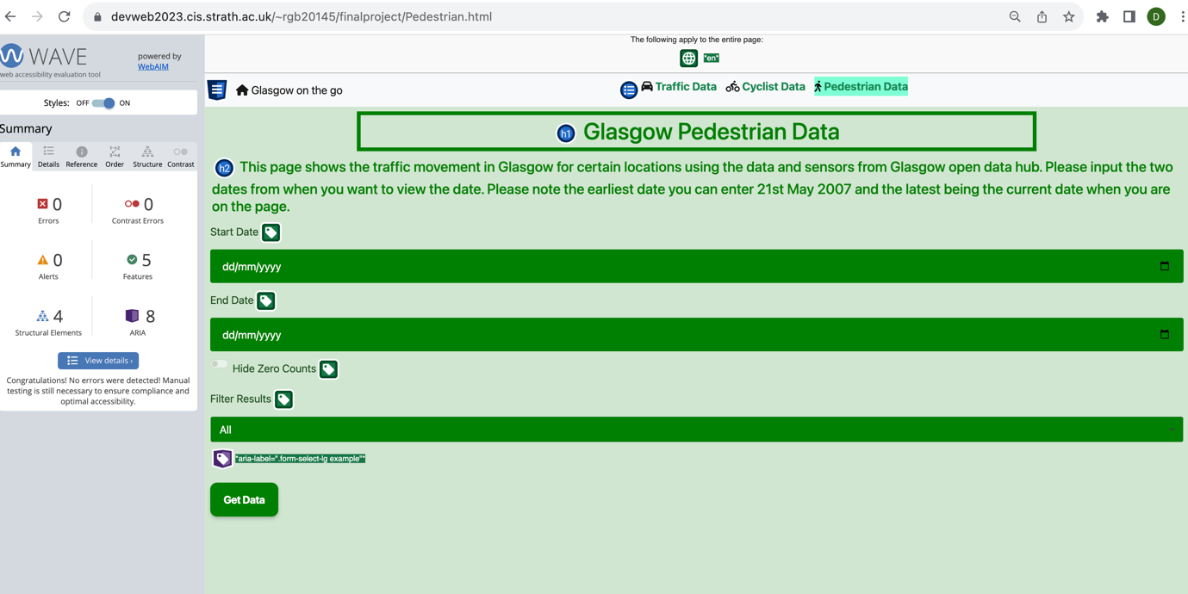

Figure 9: This shows the Wave Tool applied to the top half of the Pedestrian Page which shows there are no issues, and it is compliant with accessibility standards.

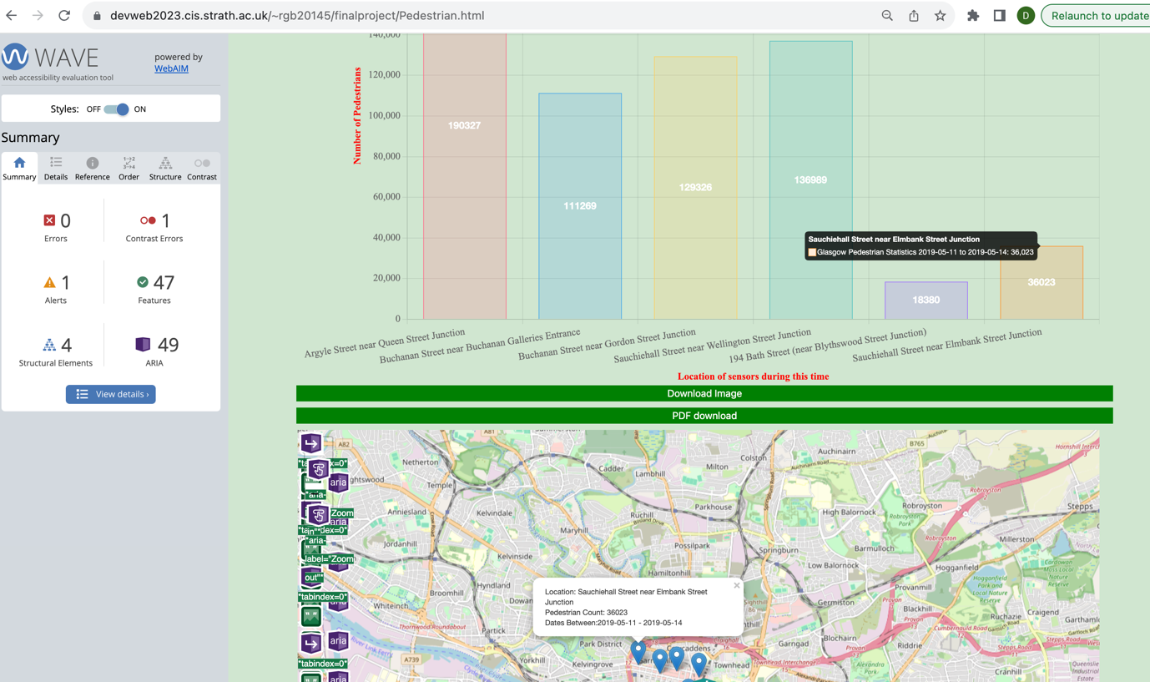

Figure 10: This shows the Wave Tool applied to the second half of the Pedestrian Page which shows there are no issues, and it is compliant with accessibility standards.

# Verification and Validation

## Testing Strategy

This chapter delves into the rigorous testing strategy used to ensure my final application met the highest standards of quality and functionality. It encompasses an in-depth exploration of the multi-layered testing process, which includes unit testing to validate individual components, user testing to assess the user experience, and continuous testing throughout the development cycle to maintain code integrity and address issues in real time.

## Testing During Development

During development user input for inputting the start and end date was tested. This ensured input was valid and in line with the timeline available for the data depending on the active page (pedestrian, cyclist or traffic). For instance, if a user enters a date that is not in range, or an invalid format and then clicks the submit button a helpful informative message shows on screen guiding them on what to change in their input. This is just one type of validation done by one of the functions within the model class, meticulously designed to pre-empt potential errors before any API requests are made to the server. Please see Appendix A for more details.

## User Testing

Given the user-centric design of the application user testing was indispensable and a no-brainer. The user testing was structured methodically evaluating each page of the application and its features. A diverse group of participants, including classmates and friends, were selected to represent the application’s potential user base. Participants were invited to perform a series of tasks to test the functionality and user interface of each page. These tasks are elaborated in Appendix B.

In total 21 participants contributed to this study providing a robust set of data to inform the improvement process. Following the completion of these tasks, participants were asked to complete a post-evaluation survey constructed on Qualtrics. This survey aimed to capture detailed feedback on their experience, including any difficulties encountered and the intuitiveness of the application workflow. The valuable insights derived from this survey will be dissected and discussed in detail in the next chapter.

## Unit Testing

In the development of the application unit testing was carried out through a browser-based unit-testing approach which was adopted to validate the functionality and robustness of the system. This decision was made based on the application being a client-side JavaScript Program which negated the need for server-side testing frameworks such as Jest. The unit tests were designed to ensure that the core functionalities and the application behaviour were as expected. The different types of tests conducted through the browser:

* **MVC Component**: This ensures the correct instantiation of Model, View and Controller objects and ensures they interact correctly, which is fundamental to both the application and MVC architectural integrity. These tests confirm the application’s structure and ensure each cog is running smoothly.
* **Data Validation**: The application is reliant on user input for date ranges, tests were implemented to check for invalid dates, ensuring that future dates are flagged and that start dates precede end dates. Thus, overall maintaining the logical flow of data processing within the application.
* **API Response Handling:** Simulated API calls to Glasgow Open Data Hub which ensures the application receives the correct data it needs.
* **Data Conversion to GeoJSON:** The transformation of raw data into GeoJSON is vital for the mapping functionality. Tests were written to confirm the Model's ability to generate accurate GeoJSON objects for pedestrian, cyclist, and traffic data.
* **Graph Data Conversion and Creation**: To ensure the application effectively translates raw data into a visual graph, a series of tests were developed. These tests validate the data formatting process for graph compatibility and confirm the accurate rendering of the graph based on the transformed data.

Implementing these tests directly in the browser environment, where the application ultimately will be deployed and run. It provides a clear straightforward and immediate context for validation. Moreover, it allowed for the testing process to be transparent and accessible, as shown in Appendix D, which illustrates both the test code and the resulting output. The benefit behind this direct form of testing is it can be used for any situation and immediately provide feedback, as well as enhancing the application’s reliability for end users.

# Results & Evaluation

This section presents the results of the ‘Glasgow on the Go’ application. The final application is a user-centred design that integrates urban mobility data and interactive visualisations. It features an intuitive interface, addressing the primary functional and non-functional requirements set out at the start of the project.

## User Experience Evaluation

Following the completion of user testing described in the previous chapter, a detailed survey was published through Qualtrics to capture participants’ feedback. This section collates their responses, providing valuable insights into the application’s usability and user satisfaction.

### Positives

The post-user testing survey revealed several strengths of the application that directly relate to its design and functionality:

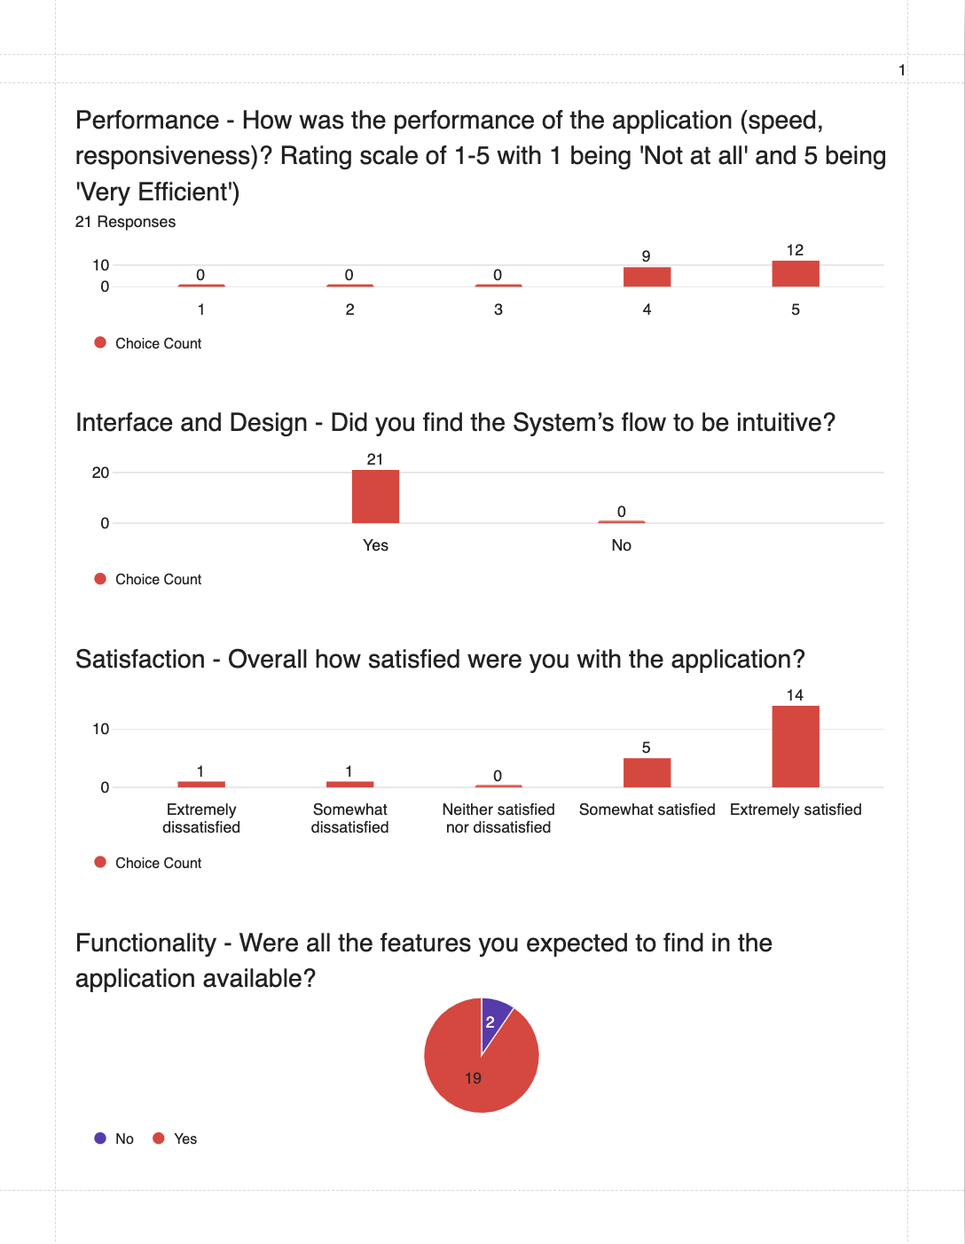

Figure 11: Shows a breakdown of some user survey questions regarding the application.

### Performance: Most users rated the application’s speed and responsiveness as ‘Very Efficient’. This reflects positively on the data processing and the interactive elements of the application, which were particularly evident in user comments, about seamless graph updates and map responsiveness.

### Interface and Design: The unanimous agreement on the system's intuitive flow speaks to a core non-functional requirement that it must be easy to navigate.

* **Satisfaction:** High levels of user satisfaction indicate not only that the application is fulfilling its intended system use cases but doing so in a way that resonates positively with end-users.
* **Functionality:** 90% of the users found all the expected features available, this shows the application has achieved most of the functional and non-functional requirements. This includes use cases such as filtering data to view specific data or download data for external use, confirming that the application provides comprehensive functionality to meet various user needs.

These correlations between the user feedback and the application's defined requirements underscore the success of the development process in creating a user-friendly, efficient, and purposeful application.

### Negatives

The feedback gathered from the Qualtrics survey revealed a few aspects of the application that need refinement:

* **Scrolling:** When posed with the question of “any points where you felt unsure or what to do next?”. Some users stated they did not realise they had to scroll down to find the map on their screen. This suggests that the visual cues for scrolling are not sufficiently intuitive or prominent.
* **Design:** Some usersdid not like the minimalist approach to the design of the homepage and the overall colour scheme of the application, even though it met WCAG standards. It is also essential to strike a balance between accessibility and user preferences for a visually engaging experience.

### Possible Improvements

The insights gained from the user feedback serve as a compass for future development:

* **Enhanced Navigation**: To better accommodate users who may not intuitively scroll, alternative design solutions like a 'scroll to view' indicator or repositioning elements on the page could be considered through media queries.
* **Design Variations**: Considering the varied design preferences, offering theme options or allowing users to customise the colour scheme could enhance user satisfaction without compromising the clean aesthetics of the application.

These proposed enhancements align with the application's commitment to meeting functional and non-functional requirements and addressing the user stories and use cases that form its foundation. By continually integrating user feedback, the application can evolve to better serve its user base and enhance its utility in urban mobility planning.

## Comparison with Specification

In comparing the final application to the original specification, it is evident that the core objectives have been met. The ability to navigate data, interact with visual elements, and operate across platforms was not only envisioned but successfully implemented. User stories and system use cases provided a compass throughout the development journey, guiding feature integration and ensuring the application's relevance to end-users.

## Final Evaluation of Application

Reflecting on the project from the start to deployment, 'Glasgow on the Go' stands as a testament to agile development and user-centred design. It has addressed the key requirements and delivered a robust platform that not only informs but also engages its audience about Glasgow’s urban mobility. The journey, while marked by iterative challenges and learning opportunities, has resulted in a product that is both functional and forward-thinking, laying a foundation for future enhancements and a broader application. Therefore, I would say the project has been largely successful overall.

# Summary and Conclusion

This final chapter reflects on the triumph of achieving the stated aims and objectives. It also discusses potential improvements and areas for extension in the future, as well as summarising the project in general.

## Project Reflection

Reflecting on the project, it is evident that 'Glasgow on the Go' has effectively met its core objectives, delivering a user-centric tool that has enriched the understanding of urban mobility in Glasgow. The development process itself was marked by a series of iterative refinements, each informed by user feedback and technical insights, which steered the project towards great success.

## Future Development

This section gives an insight into the next steps for anyone wanting to take this project further in the future. These improvement suggestions come from my own personal experience and user evaluation.

### Short-Term Development Opportunities

To further align the application with accessibility standards, I would recommend comprehensive testing with screen readers, ensuring all interactive elements are fully accessible. This will further ensure adherence to WCAG 2.1 AA standards. Additionally, consider user preferences, starting with a feature to customise the colour scheme of the application which was highlighted in the user evaluation.

### Long-Term Development Opportunities

Due to the instability of the API, establishing a local SQL database would allow for closer management of the data and store only the relevant information needed. This may cause an issue with storage over time, but the trade-off for reliable performance could prove more valuable. Moreover, expanding the filtering options to facilitate side by side comparisons between different mobility categories (pedestrian, cyclist and traffic), would provide a richer analytical experience for users.

## Conclusion

To conclude, the creation of the application has been remarkably rewarding, and I am pleased with the outcome. The project, while more demanding than initially anticipated, has significantly contributed to my growth as a computer scientist. I hope this application can be a blueprint for other cities as well as Glasgow for how we view urban mobility.

# Bibliography

|  |  |
| --- | --- |
| [1] | D. Sandelands, “Glasgow Times,” 29 June 2021. [Online]. Available: https://www.glasgowtimes.co.uk/news/19404825.latest-figures-show-rise-glasgows-population-due-net-migration/#:~:text=THE%20latest%20population%20figures%20for,and%2028%2C740%20left%20the%20city. [Accessed 21 11 2023]. |
| [2] | P. Barlett, 12 February 2022. [Online]. Available: https://news.stv.tv/west-central/glasgow-public-transport-the-worst-its-ever-been-say-residents. [Accessed 21 11 2023]. |
| [3] | E. a. S. Vergura, “https://ieeexplore.ieee.org/document/7177648,” 16 June 2015. [Online]. Available: https://ieeexplore.ieee.org/document/7177648. [Accessed 21 11 2023]. |
| [4] | G. Milner, “What a Big Data Approach and Geospatial Tools Reveal about Human Mobility,” 7 September 2021. [Online]. Available: https://www.esri.com/about/newsroom/blog/big-data-geospatial-tools-reveal-human-mobility/. [Accessed 23 11 2023]. |
| [5] | E. F. Zambom Santana, N. Lago, T. Martins and H. Amario de Souza, “Visualizing the structure of urban mobility with bundling: A case study of the city of São Paulo,” 1 October 2020. [Online]. Available: https://www.researchgate.net/publication/344874195_Visualizing_the_structure_of_urban_mobility_with_bundling_A_case_study_of_the_city_of_Sao_Paulo. [Accessed 21 11 2023]. |
| [6] | Glasgow City Council, “Glasgow Open Data Hub,” [Online]. Available: https://data.glasgow.gov.uk/. |
| [7] | “Engaging Data,” [Online]. Available: https://engaging-data.com/. |
| [8] | “Cors Proxy IO,” [Online]. Available: https://corsproxy.io/. |
| [9] | R. T. Fielding, “Architectural Styles and the Design of Network-based Software Architectures,” University of California, Irvine, 2000. |
| [10] | Leaflet, “Leaflet,” [Online]. Available: https://leafletjs.com. |
| [11] | R. Grant, “Review of Data Visualization: Charts, Maps, and Interactive Graphics,” 22 01 2021. [Online]. Available: https://doi.org/10.1080/00031305.2020.1865062. |
| [12] | “Chart JS,” [Online]. Available: https://www.chartjs.org/docs/latest/. |
|  |  |

The method on line 392 ensures the start date is before the end date and the other method on line 401 ensures for the data type (i.e. pedestrian cyclist or traffic) there is data recorded between that timeline.

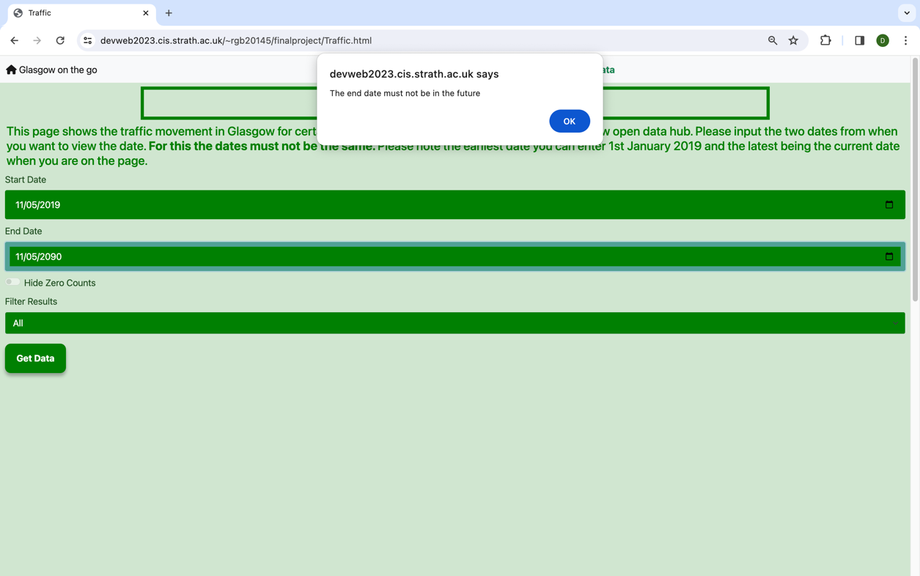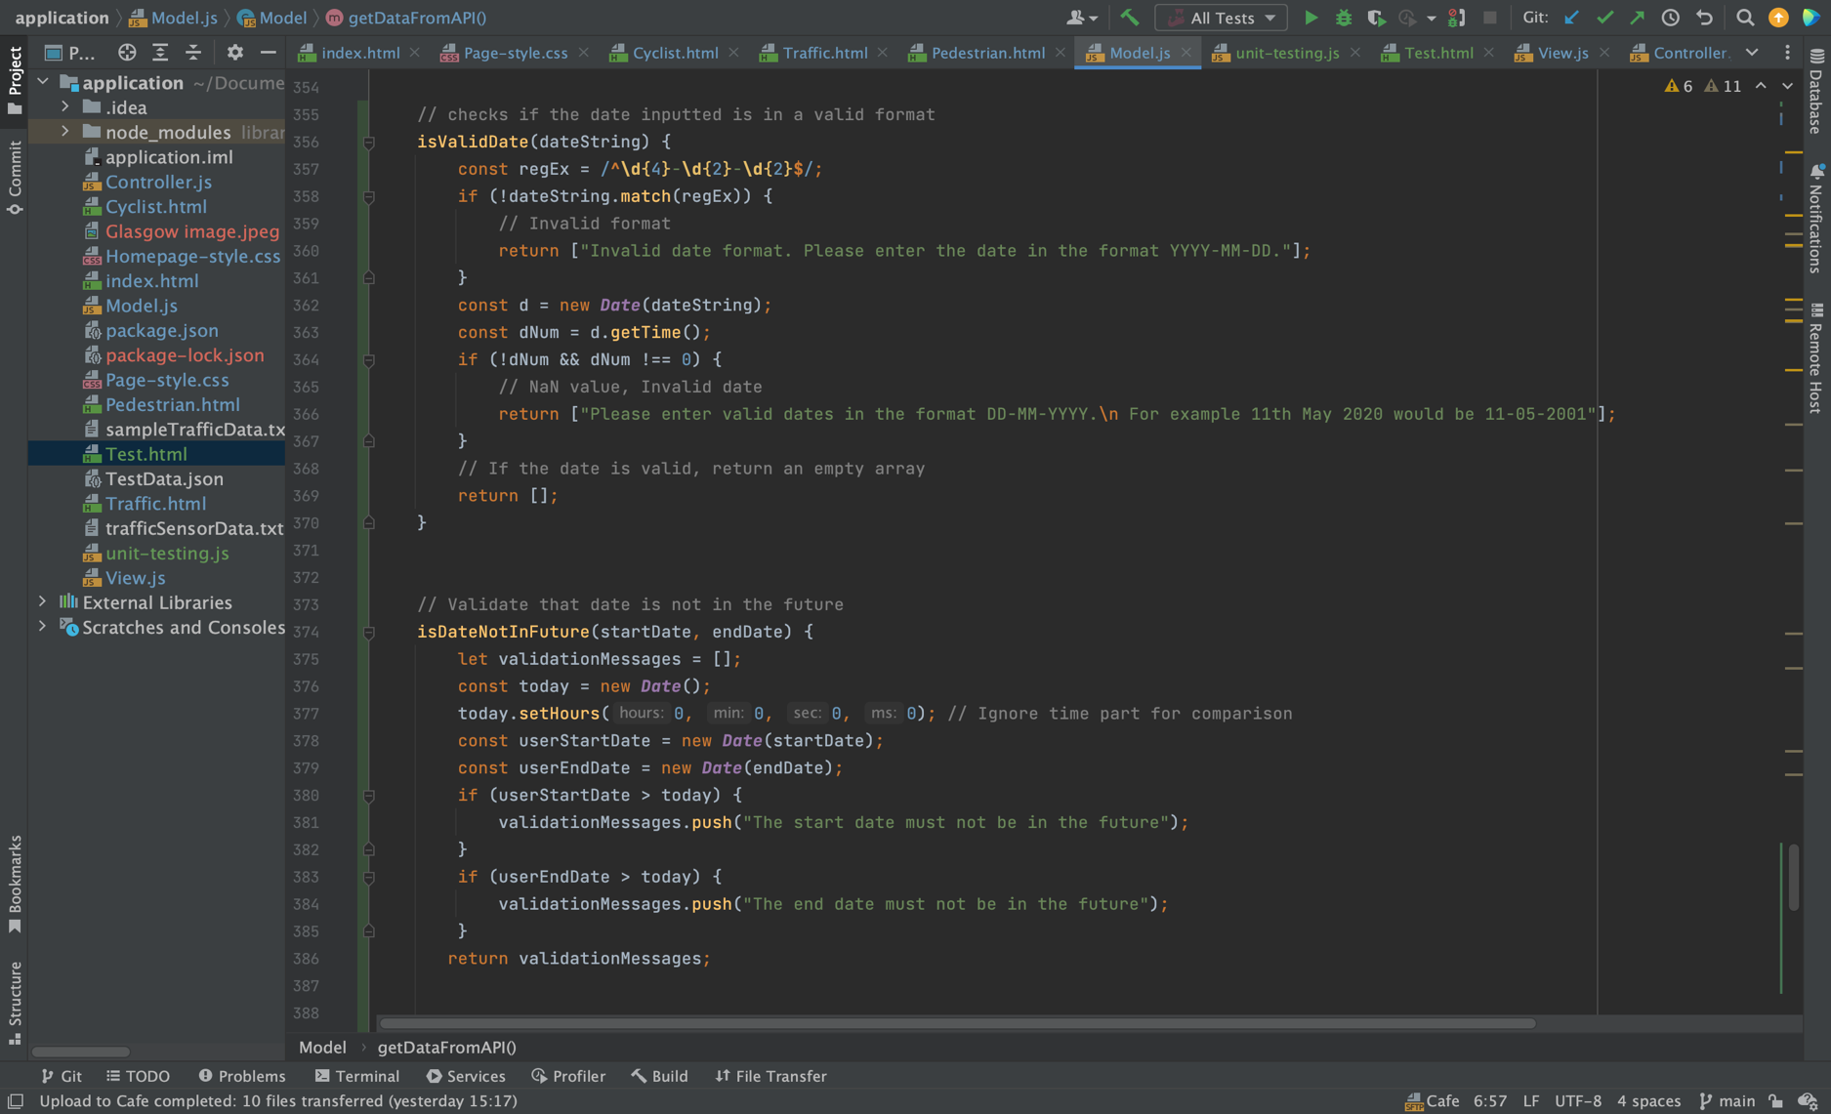The ‘**isValidDate(dateString)’** ensures the user has inputted the date in the expected format and ‘**isDateNotInFuture(startDate,endDate)**’ checks to ensure the date inputted is not in the future. You can see an example of this in action below.

# Appendix B- User Testing and User Evaluation:

## Ethical Approval Form

Ethics approval for the experiment was granted by the Department of Computer and Information Sciences Ethics Committee.

## Consent Form

**Outline**

This document highlights your rights and important information as a tester in this study. Please note you can exercise your rights at any point in time and it will be carried out in no less than one month.

**User Tester Rights**

As a participant in this process, you have the following rights:

* The right to withdraw from the process at any time and under any circumstances. This ranges from factors such as feel stressed, overwhelmed or running out of time.
* There is no obligation at all for you to complete this process.
* The right to decline to answer a certain question.
* The right to data erasure. If you feel like you don’t want your data to be stored and analysed anymore, contact me as soon as possible and your data will be erased from the process.
* The right to data rectification. If you wish to change data that is incorrect, you will be able to do so.

**User tester consent**

* I confirm that I have read and understood the Participant Information Sheet for the above project and the researcher has answered any queries to my satisfaction.
* I confirm that I have read and understood the Privacy Notice for Participants in Research Projects and understand how my personal information will be used and what will happen to it (i.e. how it will be stored and for how long).
* I understand that anonymised data (i.e. data that do not identify me personally) cannot be withdrawn once they have been included in the study.
* I understand that any information recorded in the research will remain confidential and no information that identifies me will be made publicly available.
* I understand my opinion will be truthful and contribute to form a general opinion of the application and its performance.
* I consent to being a participant in the project.

## User Tasks

I would recommend using Chrome or Firefox if using a laptop or PC. Please click here to open the web application in a new tab. Then proceed to complete a series of tasks below to the best of your ability. This should take no more than ten minutes.

* Please navigate to the pedestrian page select two weekends of your choice and compare the pedestrian count. Note any significant differences in the count volume by analysing the graph results. If you hover over each point, it says the exact number for that sensor. Using the map as well as zooming in and out and clicking on the pop-ups to view the sensor data.
* Please review the available data for the current year to determine the number of active cyclist sensors recording data. Once you have this number, using the trends you observe, estimate how many sensors you would expect to been active in 2017. Consider factors such as urban development, environmental initiatives, and historical growth patterns in your estimation.
* Navigate between the Pedestrian, Cyclist, and Traffic tabs. Observe the response time of the graph and map when switching between these tabs and note any delays or issues.

* Use the 'Hide Zero Counts' feature to filter the data for two inputs of your choice on the traffic page. Does this make it easier to analyse the days with active traffic?

* Download the traffic data for cyclists as an image and a PDF. Assess the quality of the downloaded files and the ease of this process.
* Hover over the graph to see the data points. When you click on a data point, does it open the corresponding popup on the map?

## Survey Questions

A short user survey was conducted after users had completed the tasks.

**Ease of use:**

* Were there any tasks that were difficult to complete?
* If your answer for the above question was “yes” please specify which tasks and why. If your answer is “no” please write NA.

**Interface and Design:**

* Did you find the System’s flow to be intuitive?
* Please specify why or why not for the above question

**Functionality:**

* Were all the features you expected to find in the application available?
* Did the application perform all the tasks you needed efficiently?

**Navigation:**

* How easy was it to navigate between different pages and features?
* Were there any points where you felt lost or unsure of what to do next?

**Satisfaction:**

* Overall were you satisfied with the application?
* What was your favourite part about the application?
* What was your least favourite part about the application?

**Performance:**

* How was the performance of the application (speed, responsiveness)?
* Did you experience any technical issues or bugs? If so, please explain.

**Recommend to others:**

* How likely are you to recommend this application to others?
* What would make you more likely to recommend this application?

# Appendix C- User and Maintenance Guide

## Prerequisites

Before running the ‘Glasgow on the Go’ application is it important to check the device you are using:

* Is Wi-Fi enabled.
* You are running the latest browser on Chrome or Safari.
* If using Safari, ensure it is only on mobile as there can be glitches when using the application on a laptop or PC.

## Accessing as a User

You can access the application using the link below that will take you to the homepage:

<https://devweb2023.cis.strath.ac.uk/~rgb20145/finalproject/index.html>

## Deploying the Application as Maintainer or Developer

Please use this link to access the Glasgow Open Data Hub’s numerous APIs <https://developer.glasgow.gov.uk/api-details#api=mobility>.

**Local Setup and Libraries:** Before launching the application, verify that all local libraries cited within the HTML files are downloaded and appropriately linked. This guarantees full functionality offline and removes dependency on external Content Delivery Networks (CDNs).

**Application Structure:** The **index.html** file functions as the home page of the application. Additional HTML files, specifically **pedestrian.html**, **cyclist.html**, and **traffic.html**, correspond to their respective sections of the application. **Homepage-style.css** style sheet is applied exclusively for the homepage (**index.html)**. **Page-syle.css** is applied to the individual pedestrian, cyclist and traffic HTML pages.Segregating styles in this manner allows for easier maintenance and modifications to the visual aspects of distinct sections within the application without unintended effects.

**MVC Architecture:** The application adheres to the Model-View-Controller (MVC) architecture. For seamless operation, confirm that the subsequent scripts are incorporated and executed in the given sequence:

* **model.js**: Contains the logic for data management.
* **view.js**: Manages the user interface components.
* **controller.js**: Facilitates communication between the model and view.

**Hosting:** At present, the application is hosted on the DEVWEB server, though it is feasible to deploy it to alternative hosting environments. Should you opt for migration, ensure the chosen platform is compatible with the application’s technology stack and that environmental variables along with server configurations are correctly established.

**Testing:** For testing purposes, execute **test.html** within a web browser. This document should be linked to the **unit-testing.js** script which contains the tests. Verify that the tests encompass all functionalities and are successfully passed without discrepancies.

**Directory Structure:** Maintain an organised structure by placing all files, encompassing HTML, CSS, JavaScript, and any supplementary resources, within the same directory to avert issues related to file paths.

**Deployment:** For the deployment process, the codebase can be pushed to a Git repository and subsequently to a server.

# Appendix D- Unit Testing

A total of 18 unit tests were created for the application. All the tests can be found in the project source code titled ‘unit-testing.js’ To run these tests execute the ‘Test.html’ in a browser which will tell you what they check for and if they pass or not.

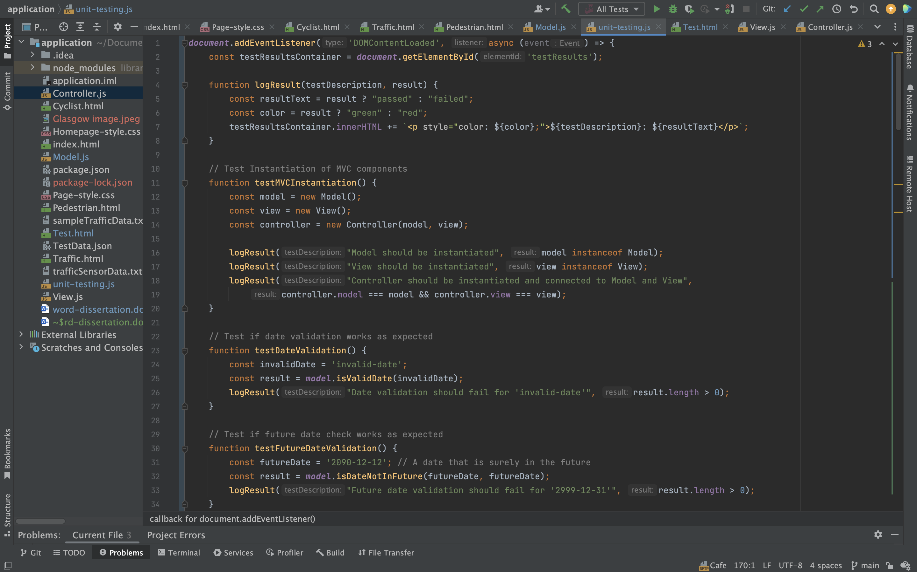**MVC component Tests: Code to test the instantiation and interaction of Model View and Controller Objects.**

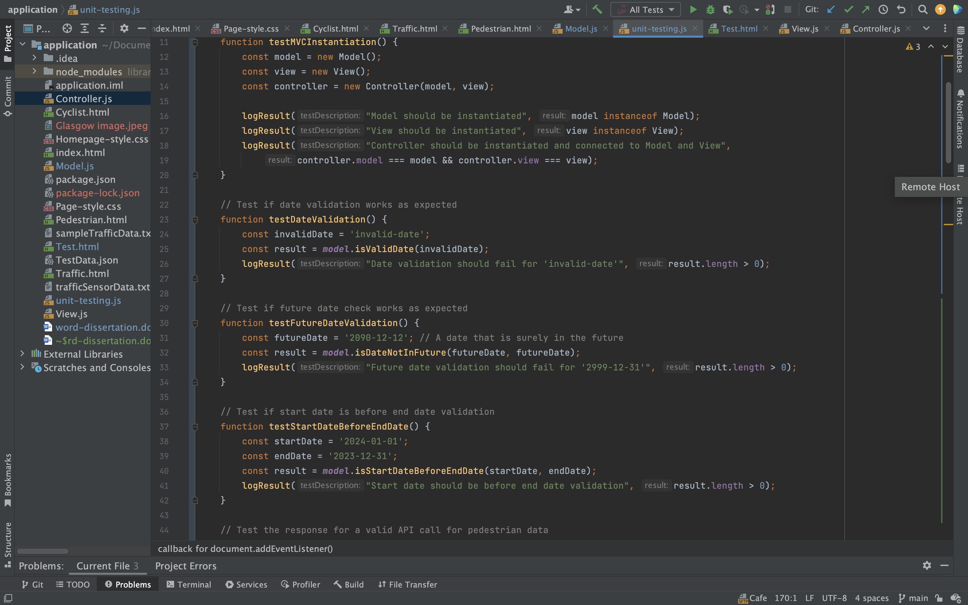**Data Validation Tests: Code that checks the validation logic for user input, such as date ranges.**

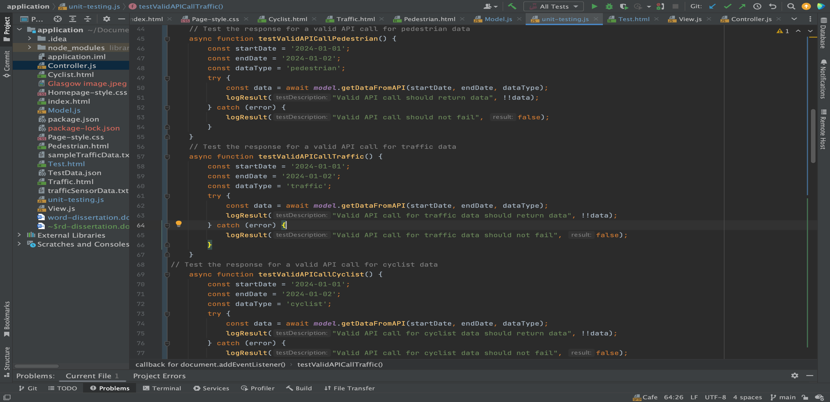**API Response Handling Tests: Simulated API call tests and the handling of responses.**

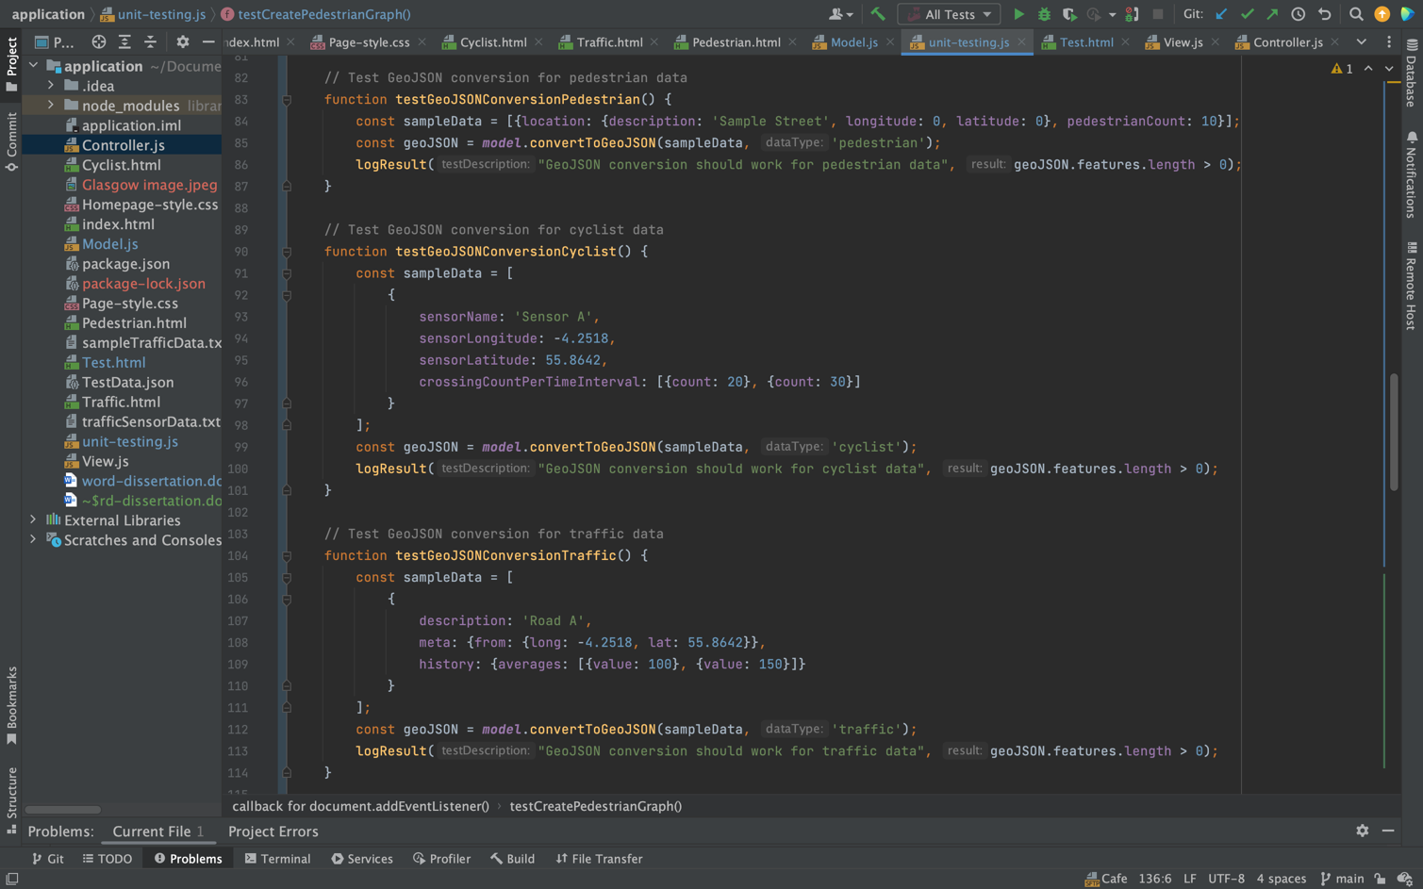**Data Conversion to GeoJSON Tests: Code that verifies the transformation of raw data into GeoJSON format.**

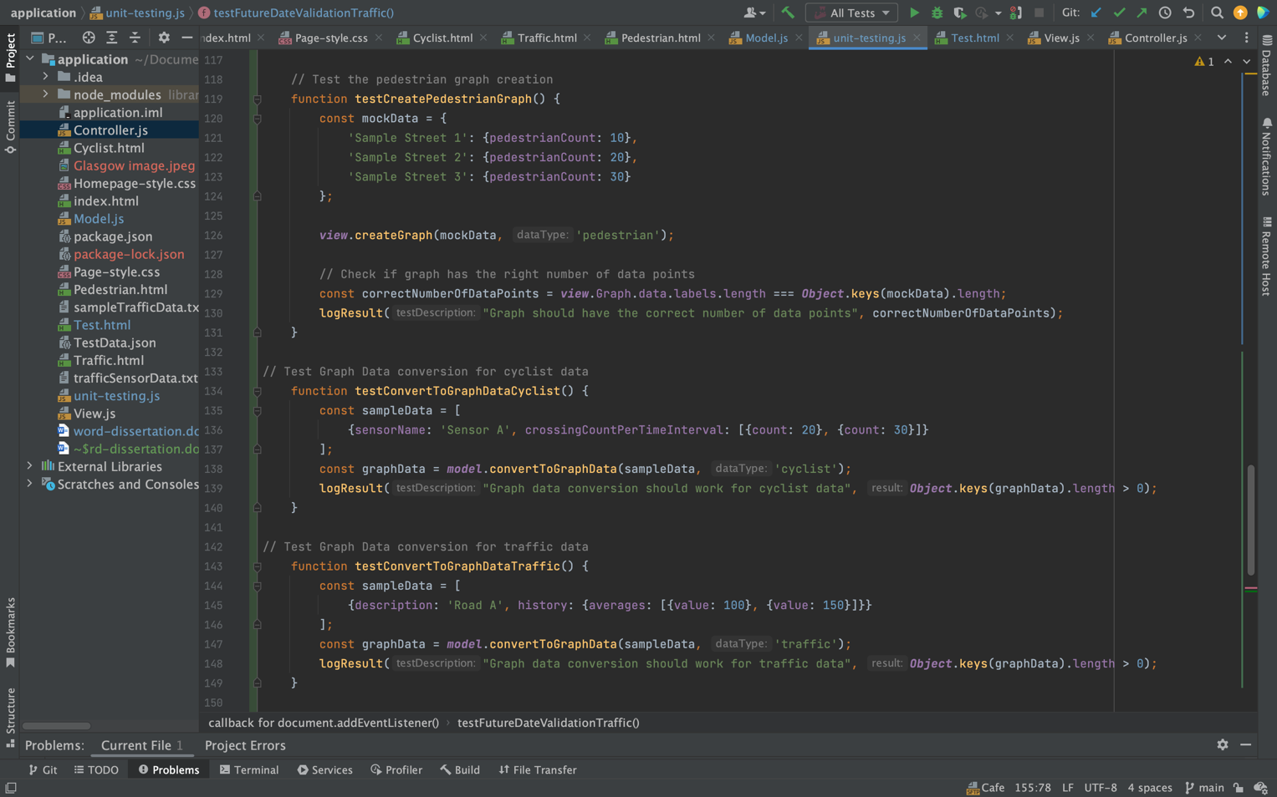**Graph Data Conversion and Creation Tests: Tests to confirm the proper translation of data for graph representation.**

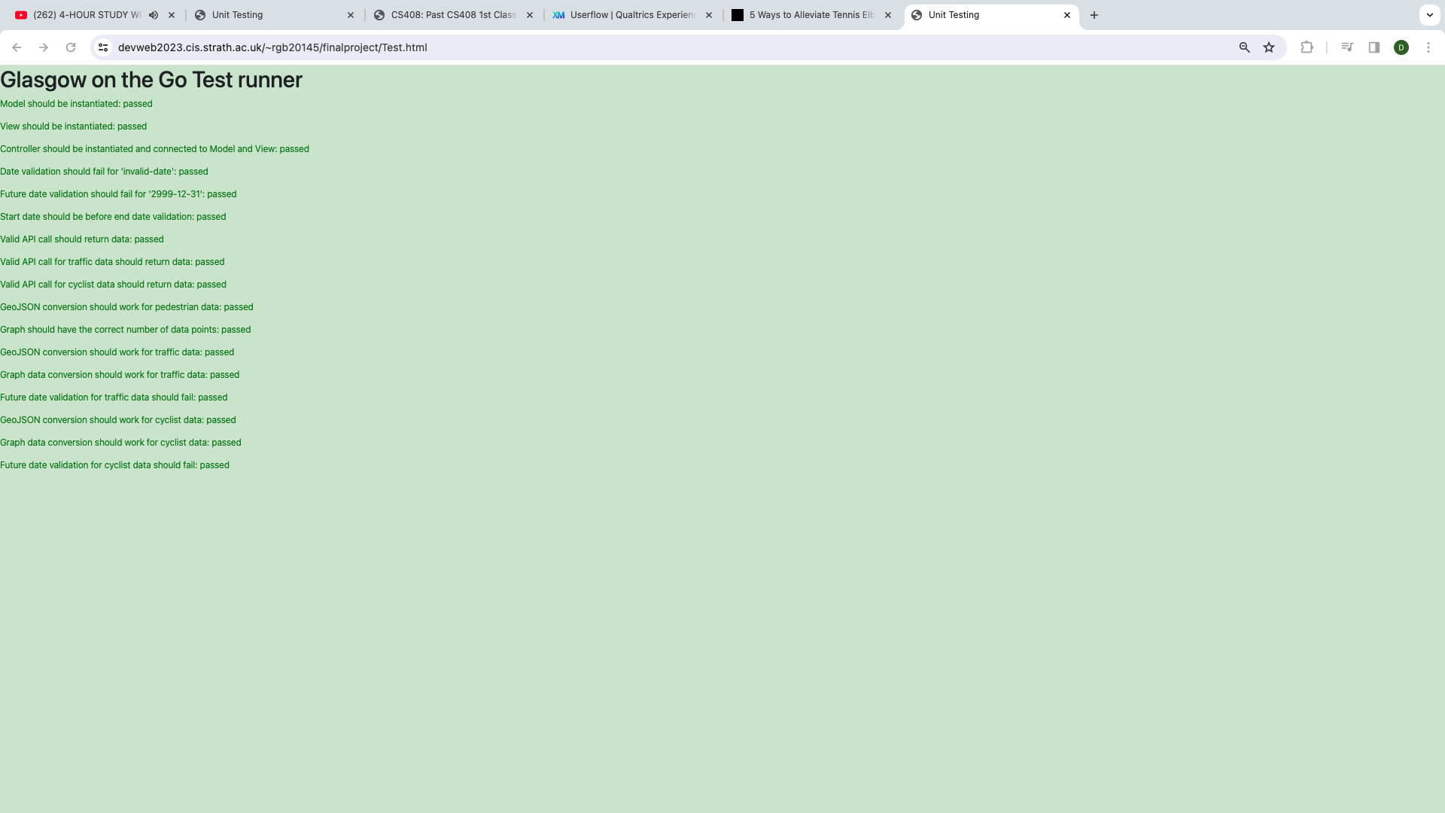 **Results of Test.html being run on the browser.**